***

Build a Classification Model for Drug Trials Dataset

**Internship report**

**Submitted to**

Department of Statistics

**Faculty of Science & Technology**

**Under TCS ION INDUSTRY HONOUR PROGRAM**

**Vishwakarma University, Pune (Maharashtra)**

**By**

**Megha. S. Sharma**

Under the supervision of

|  |  |  |  |
| --- | --- | --- | --- |
| |  |  | | --- | --- | | Industry Mentor  Mr. Harish Kumar.  Tata consultancy services | Faculty MENTOR  Dr. Madhuri Pant  Vishwakarma university, pune | |  |

**CERTIFICATE**

This is to certify that the project of titled “Build a Classification Model for Drug Trials Dataset“ submitted by Megha Sharma is an original work and has not been previously submitted in part or full for the award of any degree or diploma to this or any other university. The project is submitted to Vishwakarma University Pune and TCS-ION Industry Honor Program, in partial fulfillment of the requirement for the award of the degree of Master of Science in the subject of Statistics-Big Data Analytics

Date:30-05-2023

**Dr. Madhuri Pant**

**Faculty Mentor**

**Dr. Nazia Wahid**

**Head of Department**

**(Mathematics and Statistics)**

**DECLARATION**

Hello,

Megha sharma (202100703)

Here by declare that the work embodied in this project entitled “ Build a Classification Model for Drug Trials Dataset” carried out by under the supervision of Industry mentor MR. HARISH KUMAR & Faculty mentor DR. MADHURI PANT Assistant Professor, Faculty of Science & Technology, Vishwakarma University, Pune is an original work and does not contain any work submitted for the award of any degree in this university or any other university.

**Megha Sharma**

M.Sc. Statistics-Big Data Analytics,

Department Of Mathematics & Statistics,

Vishwakarma University, Pune.

|  |  |  |  |  |
| --- | --- | --- | --- | --- |
| Start Date | End Date | Total Effort (hrs.) | Project Environment | Tools used |
| 03/05/2023 | 16/06/2023 | 210 | Python | Google Collab, Paint |

**ABSTRACT**

This project report is written to describe my internship activities and key reflections on what I learned during 210hrs internship at TCS ion, India.

* The first week of the internship was spent in Visiting basic concepts of classification model. To better understand the procedure of applying chosen machine learning model on the selected dataset. Through the codes were provided by TCS , I got well acquainted with applying Scikit machine learning model on the dataset provided by TCS and its Prerequisites.
* I used Drug Dataset from Kaggle

//drive.google.com/file/d/1LfRqs71zp7uu28XZK9PHSA6sGDr5miMA/view?usp=sharing

* This dataset is about how different features determine if salary will be higher or greater than 50000.
* After getting well-versed with the concepts regarding this internship. The Project environment was preferred to be Python.
* I applied different machine learning model on my chosen dataset after going through the required pre requisites. Selected dataset was indexed and before using the ML model, I derived insights from the indexed , carefully chosen  dataset using EDA. Data was thoroughly studied .

**TABLE OF CONTENT**

|  |  |  |
| --- | --- | --- |
| Sr no | Table of contents | Page no |
| 1 | Acknowledgements | 6 |
| 2 | * Objectives | 7 |
| 3 | Information about the company | 8 |
| 4 | Description of dataset | 9 |
| 5 | Introduction to internship | 10 |
| 5 | Flow Diagram | 11 |
| 6 | HR Salary Dashboard -Brief walk through few steps | 12 |
| 7 | EDA | 14 |
| 8 | Label Encoding | 23 |
| 9 | Feature selection | 25 |
| 10 | Splitting dataset & Models used | 26 |
| 11 | Hyper parameter tuning | 27 |
| 12 | Confusion Matrix | 28 |
| 13 | Example | 29 |

**ACKNOWLEDGEMENT**

I have satisfaction upon completion of this project work entitled “Build a Classification Model for Drug Trials Dataset” at the Department of statistics of ‘Vishwakarma University Pune’. The project is submitted to Vishwakarma University Pune and TCS-ION Industry Honor Program, during academic year 2022-2023.

I take this opportunity to express our gratitude to Industry mentor MR. Harish kumar. & faculty mentor Dr. Madhuri pant, assistant professor, faculty of science & technology, vishwakarma university, pune for their valuable guidance and help provided us during the course of completion of the project.

I am thankful to our H.O.D Dr. Nazia Wahid for providing all necessary facilities, timely co-operation and her valuable guidance and help during the completion of my project.

**OBJECTIVE**

The objective of this project is to develop a robust and accurate classification model for drugs based on patient general information and diagnosis.

Specifically, the project aims to:

1. Gather a comprehensive dataset: Collect a diverse and extensive dataset that includes patient general information, such as age, gender, and medical history, along with their corresponding diagnoses and prescribed drugs.
2. Preprocess and clean the data: Apply data cleaning techniques to remove any inconsistencies, missing values, or outliers from the dataset. Perform feature engineering to extract relevant information and create meaningful features for classification.
3. Perform exploratory data analysis (EDA): Conduct an in-depth analysis of the dataset to gain insights into the relationships between patient general information, diagnoses, and drug prescriptions. Identify any patterns or trends that may assist in the classification task.
4. Select appropriate machine learning algorithms: Evaluate and compare various classification algorithms, such as logistic regression, decision trees, random forests, support vector machines (SVM), or neural networks, to determine the most suitable model for the drug classification task. Consider the trade-offs between accuracy, interpretability, and computational efficiency.
5. Train and validate the classification model: Split the dataset into training and validation sets. Train the chosen classification model on the training set and optimize its hyperparameters through techniques like cross-validation or grid search. Evaluate the model's performance on the validation set, considering metrics such as accuracy, precision, recall, and F1 score.
6. Fine-tune the model and address overfitting
7. Test the model's performance: Once the model is trained and fine-tuned, evaluate its performance on an independent and unseen test dataset. Measure its accuracy and other relevant metrics to assess the model's effectiveness in classifying drugs based on patient general information and diagnosis.
8. Interpret the model's predictions: Analyze the model's decision-making process to understand the underlying factors that contribute to drug classification. Identify the most influential features and provide insights into how patient general information and diagnosis influence drug prescriptions.
9. Deploy the classification model: Integrate the trained model into a user-friendly application or system that allows healthcare professionals to input patient information and obtain drug classification predictions in real-time. Ensure the system's scalability, security, and privacy considerations.
10. Evaluate and refine the model: Continuously monitor and evaluate the model's performance in real-world scenarios. Collect feedback from users and domain experts to identify areas for improvement. Refine the model iteratively to enhance its accuracy and usability.
11. By accomplishing these objectives, this project aims to develop an effective drug classification system that leverages patient general information and diagnosis to assist healthcare professionals in making informed decisions regarding drug prescriptions.

**INFORMATION ABOUT COMPANY.**

TCS iON is one of the largest online platforms for students with the TCS iON Digital Learning Hub offering a wide range of courses, assessments, and events. It also hosts digital discussion rooms designed for students to collaborate, share knowledge, and participate .

TCS iON provides technology offering end-to-end business solutions. It caters to the needs of multiple industry segments, through innovative, easy-to-use, secured, integrated, hosted solutions in a build-as-you-grow, pay-as-you-use business model.

TCS iON's Cloud Based Solution is highly modular, scalable, and configurable giving businesses and educational institutions the benefits of increased efficiencies, faster go to market, predictability of technology as well as spend and better business results. I felt their mission was compatible with my choice of career field, which is the reason I am grateful to Vishwakarma university for an internship position with TCS iON

**DESCRIPTION OF DATASET**

In the context of a medical research study, a dataset has been compiled to investigate the appropriate medication for patients suffering from a specific illness. The dataset consists of various patient attributes, including Age, Sex, Blood Pressure (BP), Cholesterol levels, and the corresponding medication (Drug A, Drug B, Drug C, Drug X, or Drug Y) to which each patient responded.

The dataset serves as a basis for developing a multiclass classification model.

The goal is to utilize the dataset's training portion to construct a decision tree that can accurately predict the appropriate medication for future patients with the same illness.

This model can then be employed to determine the most suitable drug for a new patient or predict the class (medication) for an unknown patient.

The dataset contains the following attributes:

* Age: Represents the age of each patient, indicating their chronological age in years.
* Sex: Denotes the gender of each patient, indicating whether they are male or female.
* BP (Blood Pressure): Refers to the blood pressure level of each patient, providing information about their cardiovascular health.
* Cholesterol: Indicates the cholesterol level of each patient, which serves as a significant indicator of their overall lipid profile.
* Na_to_K: Represents a specific ratio calculated from sodium (Na) and potassium (K) levels in the patient's blood, providing further insights into their physiological state.
* Drug: Corresponds to the medication (Drug A, Drug B, Drug C, Drug X, or Drug Y) to which each patient responded during their treatment.

**INTRODUCTION OF INTERNSHIP**

Details of this internship are as follows:

The objective of this project is to build a HR salary dashboard based on historical data after analysing what features effect salary the most.

* Knowledge of Python
* Knowledge of various forecasting techniques
* Knowledge of choosing the best forecasting model for your dataset.
* Knowledge of visualizing trends.

As an intern with TCS iON .While Central focus was on the HR salary dashboard project and was responsible for

applying accurate machine learning model on chosen dataset -Salary. This dataset consist of data about features that effect salary

**PREVIEW OF MY PROJECT**

1. **Data Preprocessing**
2. Stripping column name of whitespaces.
3. Checked for duplicates
4. Worked on Missing values
5. Check on invalid values
6. Removing duplicate data
7. Converting categorical feature to numerical

**2) Exploratory Data analysis**

1. We will add a new feature age group. Which will be a categorical column.

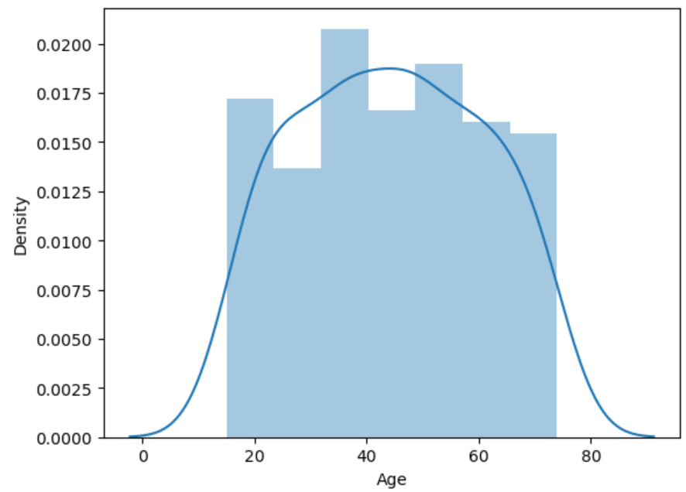 **KDE distribution of Age**

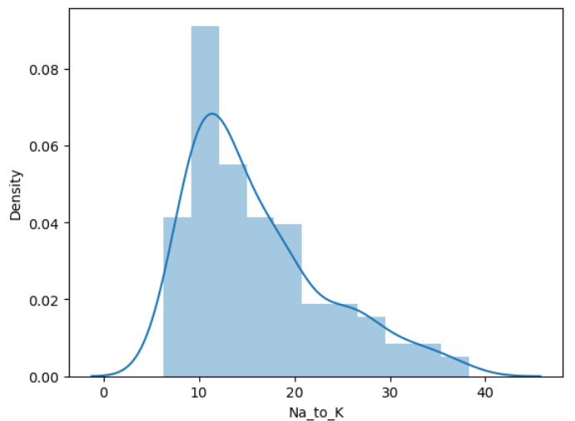

1. **KDE distribution of Na_to_K**

* The distribution of 'Age' column is symetric, since the skewness value between -0.5 and 0.5
* The distribution of 'Na_to_K' column is moderately skewed, since the skewness value is between 0.5 and 1. It can also be seen from the histogram for 'Na_to_K' column

1. 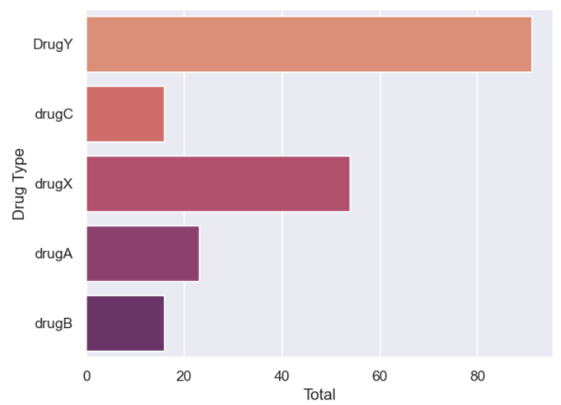**Bar chart for different types of drugs**

* The analysis of the charts reveals that DrugY is the most frequently used medication, followed by Drug X.Drug B and Drug C exhibit similar usage levels.

1. 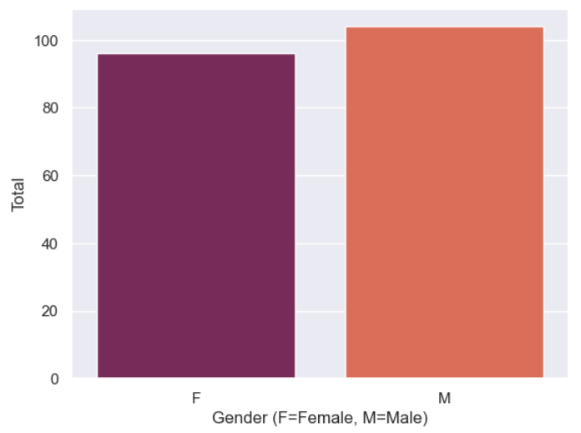**Bar chart for different types of drugs**

* The data shows a higher number of male individuals compared to females

1. 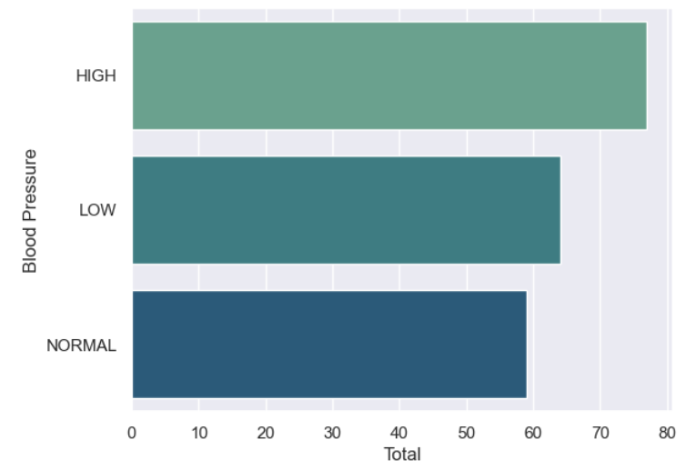 **Bar chart for different types of Blood Pressure**

* A significant majority of patients in the dataset exhibit high blood pressure, while a small percentage of individuals have normal blood pressure.

1. 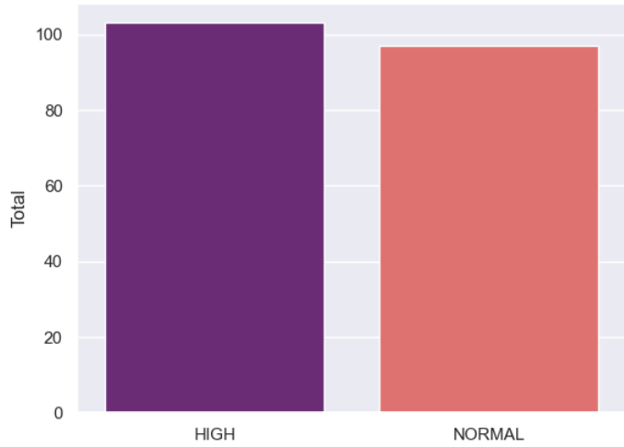 **Plot bar chart for cholestrol.**

* The number of individuals with high cholesterol has surpassed 100, indicating a substantial presence of this condition within the dataset. On the other hand, the count of individuals with normal cholesterol levels ranges between 80 to 100.

1. **Plot Gender Distribution based on Drug Type**

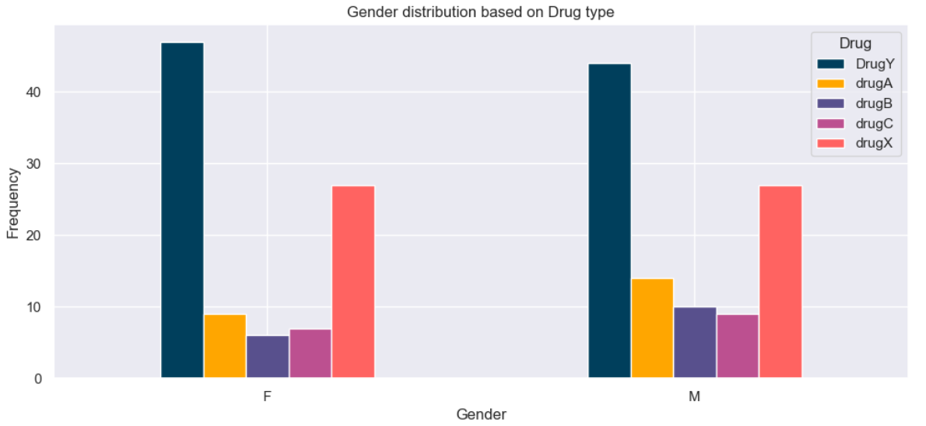

* In terms of gender distribution, the dataset comprises two groups: males and females.
* Among females, there is a higher prescription count for DrugY, exceeding 40.  
   This suggests a preference for DrugY in the female population.
* DrugX follows closely behind with a count ranging between 20-30.
* The usage of drugA, drugB, and drugC by females remains relatively low, with counts ranging from 0-10.
* Males, on the other hand, have also been prescribed DrugY, although the count is not as high as that of females.
* DrugX is the second most prescribed drug among males, with a count similar to that of females.
* The count of males using drugA is slightly higher, ranging between 10-20 more than the count of females.
* The usage of drugB and drugC among males mirrors that of females, with counts ranging from 0-10.
* Therefore, gender can play a significant role in salary determination, and addressing gender-based pay disparities is important for promoting equality and fairness in the workplace.

1. **Count of Drug based on Sex.**

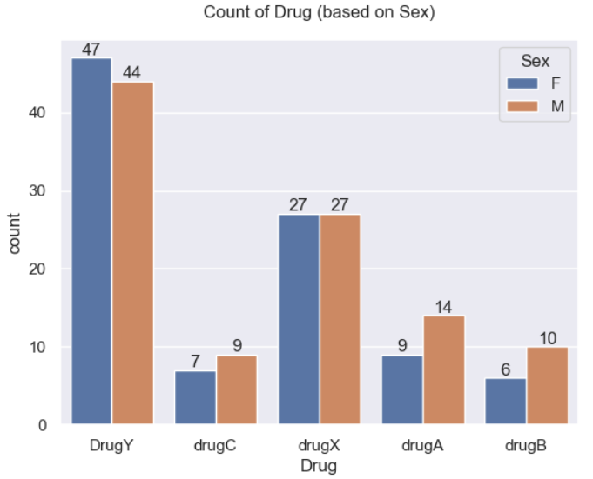

Among the five types of drugs (DrugX, DrugY, DrugA, DrugB, and DrugC), the distribution can be observed as follows:

* DrugY is used by 3 more females compared to Males , with the count of females using DrugY reaching 47.
* The count of females using DrugX is the same as DrugX itself, totaling 27 individuals each.
* The count of males using DrugA exceeds females by 5, with 14 males utilizing this medication.
* Females using DrugB are 4 fewer than males, with 6 females using this drug.
* Females using DrugC are 2 fewer than males, with 7 females using this medication.

These insights illustrate the distribution of each drug among females and males, highlighting variations in usage across the different medications.

1. 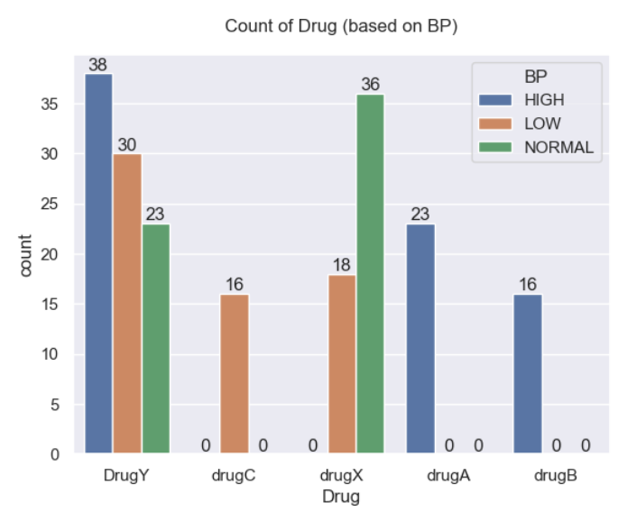**Plot of Drug based on Blood pressure.**

* Maximum number of people with all types of cholesterol level.
* Patients using DrugY, most people have higher cholesterol level(38),normal cholesterol level(23) low cholesterol level (30).
* Patients using DrugX ,people with normal cholesterol level are much higher(36) than any other drugs. With low cholesterol level (18), and higher cholesterol level at 0.
* DrugA and DrugB have only higher cholesterol level at 23 and 16 respectively.
* DrugC has low cholesterol level at 16

1. **Plot of Drug based on Blood pressure.**

Among the various types of cholesterol levels, the maximum number of patients falls into the following categories:

Patients using DrugY:

* High cholesterol level: 38 individuals
* Normal cholesterol level: 23 individuals
* Low cholesterol level: 30 individuals

Patients using DrugX:

* Normal cholesterol level: 36 individuals
* Low cholesterol level: 18 individuals
* High cholesterol level: 0 individuals

Patients using DrugA:

* High cholesterol level: 23 individuals
* Normal cholesterol level: Not specified
* Low cholesterol level: Not specified

Patients using DrugB:

* High cholesterol level: 16 individuals
* Normal cholesterol level: Not specified
* Low cholesterol level: Not specified

Patients using DrugC:

* High cholesterol level: Not specified
* Normal cholesterol level: Not specified
* Low cholesterol level: 16 individuals
* These observations provide insights into the distribution of cholesterol levels across different drugs, indicating the prevalence of specific cholesterol profiles among patients using each medication.

1. **Data Binning**

* We can see here that the minimum and maximum ages are 15 and 74 respectively and the minimum and maximum sodium to potassium ratios are 6.269 and 38.247 respectively.
* Transforming categorical variables into a form that could be provided to ML algorithms to do a better prediction
* The chemical ratio will be divided into 4 categories:

1. Below 10.
2. 10 - 20.
3. 20 - 30.
4. Above 30.

* The age will be divided into 7 age categories:

1. Below 20 y.o.
2. 20 - 29 y.o.
3. 30 - 39 y.o.
4. 40 - 49 y.o.
5. 50 - 59 y.o.
6. 60 - 69 y.o.
7. Above 70.
8. **Feature engineering**

* The FE method that used is one-hot encoding, which is transforming categorical variables into a form that could be provided to ML algorithms to do a better prediction.

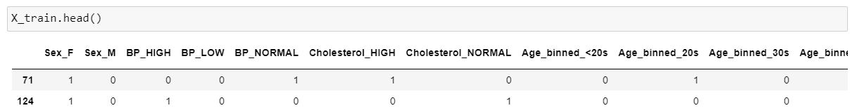



1. **Splitting the dataset**

* Splitting the dataset
* The dataset will be split into 75% training and 25% testing.



1. **SMOTE Technique**

* 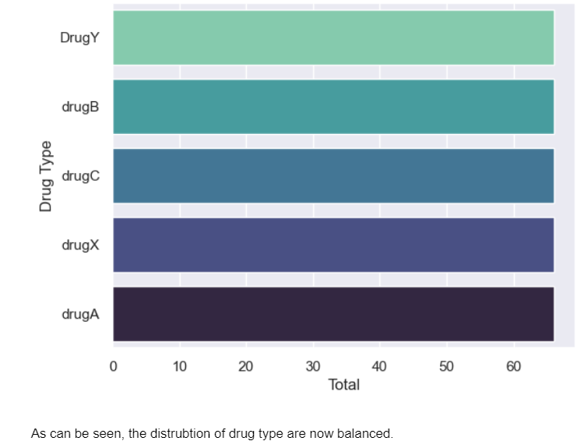Since the number of 'DrugY' is more than other types of drugs, oversampling is carried out to avoid overfitting.

1. **Models Used**

**Logistic Regression:**

* Logistic Regression is a statistical model used for binary classification problems. It models the relationship between a set of independent variables and a binary dependent variable, using a logistic function to estimate the probability of the outcome.
* It is particularly suitable when the dependent variable is categorical and the relationship is expected to be linear.
* For example, it can be used to predict whether a customer will churn or not based on various customer attributes.

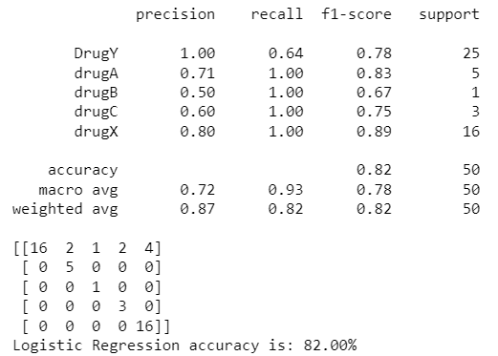

**Support Vector Machine (SVM):**

* Support Vector Machine is a powerful machine learning algorithm used for both classification and regression tasks. SVM aims to find the best possible decision boundary that separates the data points of different classes with the maximum margin.
* It is suitable for problems with a clear margin of separation between classes and when dealing with high-dimensional data.
* For instance, SVM can be used for image classification tasks where the objective is to distinguish between different objects in images.

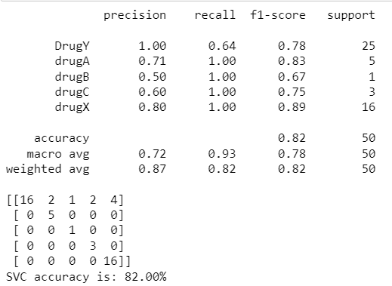

**Decision Tree:**

* A Decision Tree is a hierarchical model that uses a tree-like structure to make decisions based on feature values. It is a versatile algorithm used for both classification and regression tasks. Decision Trees are easy to interpret and can handle both categorical and numerical data.
* They work well when the relationships between features and target variable are non-linear and can handle both continuous and discrete data types.
* For example, a decision tree can be used in credit scoring to determine whether a loan applicant is likely to default or not based on their credit history and other attributes.

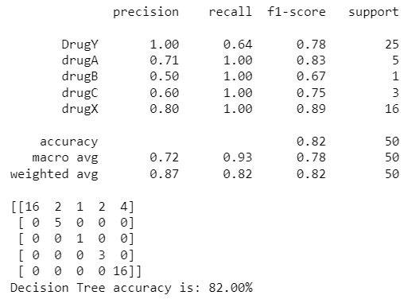

**Random Forest:**

* Random Forest is an ensemble learning method that combines multiple decision trees to make predictions. It creates a set of decision trees and combines their outputs to obtain a final prediction.
* Random Forest is suitable for classification and regression tasks and performs well when dealing with high-dimensional data with complex relationships. It is less prone to overfitting and provides feature importance rankings.
* For instance, Random Forest can be used in medical diagnosis to predict the likelihood of a disease based on a combination of symptoms and patient information.

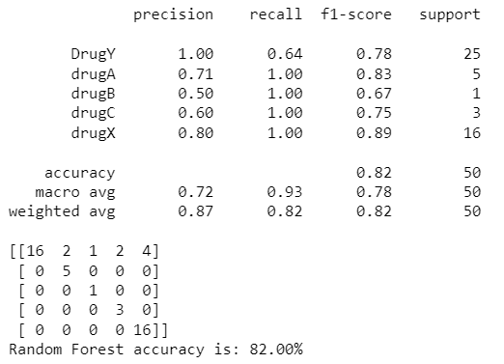

**Categorical Naive Bayes:**

* Categorical Naive Bayes is a probabilistic model based on Bayes' theorem with an assumption of independence between features.
* It is specifically designed for categorical features and is widely used for text classification tasks. Categorical Naive Bayes performs well when dealing with large feature spaces and sparse data.
* For example, it can be used in spam email classification to determine whether an email is spam or not based on the occurrence of certain words or phrases.

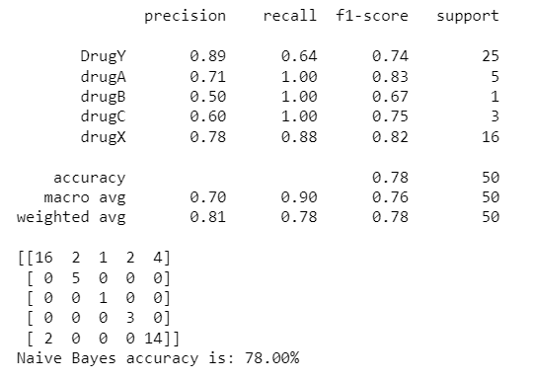

**K Nearest Neighbors (KNN):**

* K Nearest Neighbors is a simple yet effective algorithm used for both classification and regression tasks.
* It classifies new instances by comparing them to the k nearest neighbors in the training data and assigning the class label based on majority voting. KNN is suitable when the data is non-linearly separable and the decision boundaries are complex.
* For instance, KNN can be used in recommendation systems to suggest similar items or products based on the preferences of similar users.

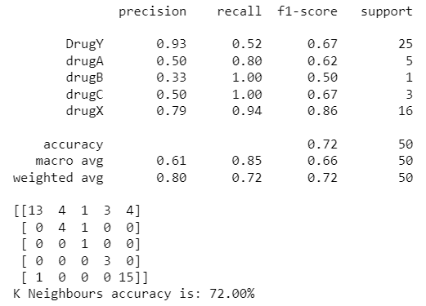

**Gaussian Naive Bayes:**

* Gaussian Naive Bayes is a variant of Naive Bayes that assumes the features follow a Gaussian (normal) distribution.
* It is commonly used for continuous numerical features and works well when the assumption of normal distribution holds.
* Gaussian Naive Bayes is suitable for classification tasks and performs particularly well when dealing with high-dimensional data.
* For example, it can be used in sentiment analysis to classify movie reviews as positive or negative based on the sentiment expressed in the text.

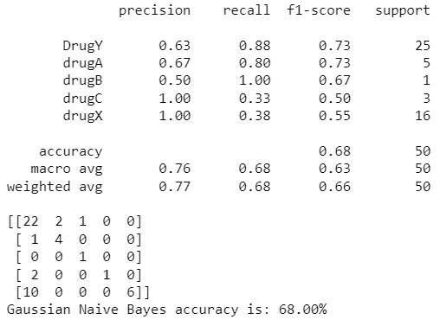

1. **L** **HYPER PARAMTER TUNING USING GRID SEARCH AND RANDOM SEARCH cv**

* Hyperparameter tuning is a crucial step in optimizing the performance of machine learning models. Grid search and random search are two popular techniques for hyperparameter tuning. The following paragraph explains how these techniques work:

1. Grid Search Cross-Validation (CV): Grid search is a systematic approach to hyperparameter tuning that involves defining a grid of hyperparameter values to explore. Each combination of hyperparameters is evaluated using cross-validation. Cross-validation involves splitting the training data into multiple subsets, training the model on a subset, and evaluating its performance on the remaining subset. Grid search exhaustively searches all possible combinations of hyperparameters in the defined grid and selects the combination that yields the best performance based on a specified evaluation metric.
2. Random Search Cross-Validation (CV): Random search is an alternative approach to hyperparameter tuning that randomly samples combinations of hyperparameter values. Unlike grid search, it does not search exhaustively through all possible combinations. Instead, it randomly selects a predefined number of combinations and evaluates them using cross-validation. random search allows for a more efficient exploration of the hyperparameter space, especially when the number of hyperparameters and their possible values is large.

* Both grid search and random search have their advantages and trade-offs. Grid search guarantees that all possible combinations are explored, ensuring a thorough search of the hyperparameter space. However, this exhaustive search can be computationally expensive and impractical for large hyperparameter spaces. Random search, on the other hand, provides a more efficient exploration by randomly sampling combinations, but it may not guarantee an exhaustive search.
* Cross-validation (CV) is an essential component in both grid search and random search. It helps assess the performance of different hyperparameter combinations in a more robust and reliable manner. By using cross-validation, the evaluation metric used to select the best hyperparameters becomes more representative of the model's generalization ability.
* To implement grid search or random search with cross-validation, machine learning libraries like scikit-learn provide convenient tools. These tools automate the process of searching through hyperparameters, training models, and evaluating performance, simplifying the hyperparameter tuning workflow.
* **Example :**

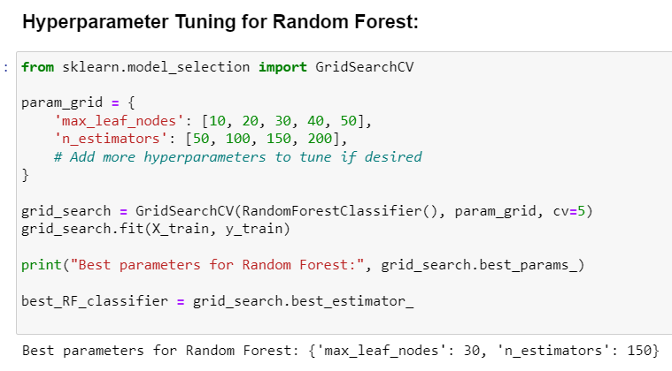

1. **Results after Hyper parameter tuning**

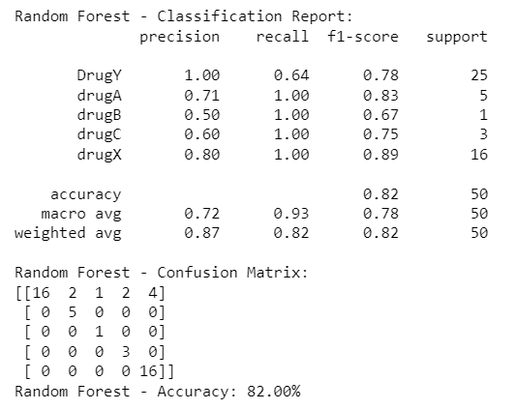 **Examples**

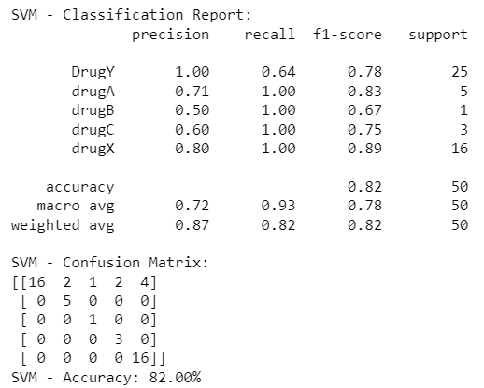

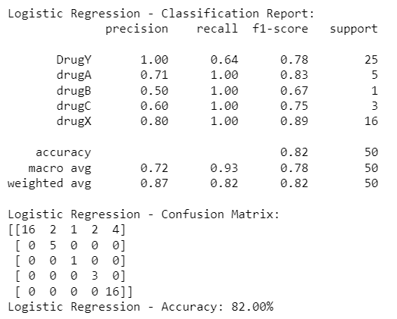

1. **Confusion matrix**

* A confusion matrix is a commonly used performance evaluation tool for classification models. It provides a comprehensive summary of the model's predictions and the actual class labels of the data.
* A confusion matrix is typically presented in a tabular form, where the rows represent the true classes, and the columns represent the predicted classes. Each cell in the matrix represents the count or proportion of instances that belong to a particular class.
* Here is an example of a confusion matrix:

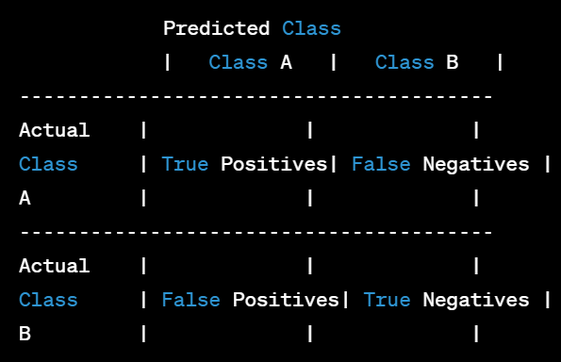

* The confusion matrix consists of four important components:

1. True Positives (TP): The number of instances that are correctly predicted as the positive class.
2. False Positives (FP): The number of instances that are incorrectly predicted as the positive class.
3. False Negatives (FN): The number of instances that are incorrectly predicted as the negative class.
4. True Negatives (TN): The number of instances that are correctly predicted as the negative class.

* Using the values in the confusion matrix, several performance metrics can be calculated to evaluate the model's accuracy, precision, recall, and F1 score. Here are some common metrics derived from the confusion matrix:

1. Accuracy: The proportion of correctly predicted instances (TP + TN) out of the total instances.
2. Precision: The proportion of true positive predictions (TP) out of the total positive predictions (TP + FP). It measures the model's ability to avoid false positives.
3. Recall (Sensitivity or True Positive Rate): The proportion of true positive predictions (TP) out of the actual positive instances (TP + FN). It measures the model's ability to identify all positive instances.
4. F1 score: The harmonic mean of precision and recall. It provides a balanced measure of the model's performance, considering both precision and recall.

* The confusion matrix is a valuable tool for understanding the strengths and weaknesses of a classification model. It provides detailed information about the model's performance on different classes and helps in identifying areas where the model might be making errors.
* By analyzing the confusion matrix, one can make informed decisions about model improvements, such as adjusting the classification threshold or considering different feature engineering techniques.

1. **Example**
2. 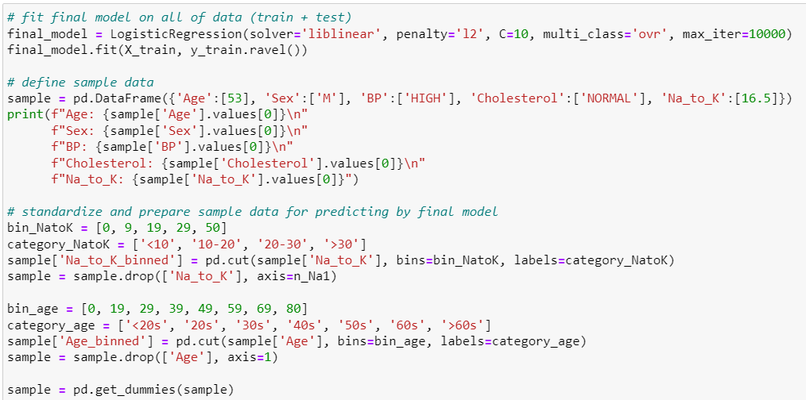

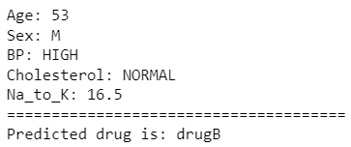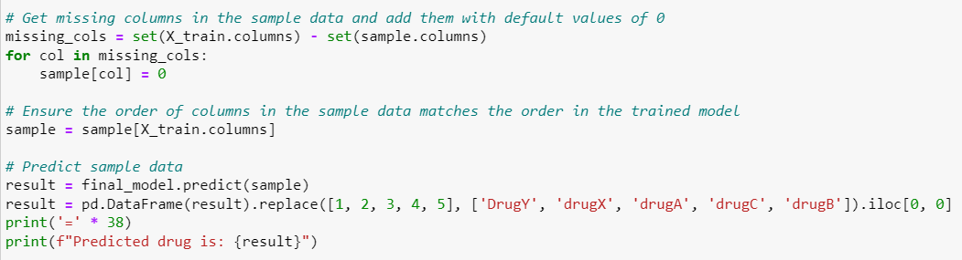

**CHALLENGES & OPPORTUNITIES**

Few of the challenge faced were

1. Data Availability: Gathering accurate and up-to-date salary data can be challenging. Used data from discussion room. It was not easy to find data suitable for this project.
2. Data Cleaning: The dataset may contain missing values, outliers, inconsistent formats, or other data quality issues.
3. Handling Large Datasets: If the dataset is large, it may pose challenges in terms of computational resources and processing time. You may need to optimize your analysis techniques or consider sampling methods to handle the data effectively.
4. Statistical Analysis: Performing statistical analysis on the dataset to uncover patterns, trends, and relationships can be challenging. It requires selecting the appropriate statistical tests, handling assumptions, and interpreting the results accurately.
5. Ensuring Data Security and Confidentiality: When working with sensitive employee salary data, maintaining data security and confidentiality is crucial. Implementing proper access controls and anonymizing data when necessary are important considerations during the analysis.
6. Interpretation and Contextual Understanding: Interpreting the analysis results and providing meaningful insights can be challenging.
7. Communication and Visualization: Presenting the analysis findings effectively through visualizations and reports is essential.

Ensuring that the visualizations are clear, concise, and understandable to the intended audience can be a challenge, requiring effective data visualization techniques.

**REFLECTIONS ON INTERNSHIP**

Being an intern was a unique experience where I was empowered, inspired and learned something new every day. I gained so much knowledge and experience I didn’t know I would have before I started. I didn’t have much experience from the Data analysis beforehand, but I knew it definitely was an industry that interested me. These experiences were challenging at times, but also allowed me to evolve and learn. My internship has taught me a lot about my skill set and given me confidence in my own abilities. It has helped guide my career aspirations and will help me in my future career choices. I also gained technical knowledge in both digitization and in the energy sector. I left my internship with a toolbox much fuller than when I started. The knowledge I gained will help me to face the real-world post-graduation. My experience has brought me closer to my goals and I am excited for what the future must bring!

I really feel that some of the most important skills you learn in college come from internships. They let you reflect on your skill base and let you see where you may need more experience as well as guidance. Here is a bit on what I learned in the past few months:

**Lesson 1: Every industry is different**

**Lesson 2: Always be learning**

**Lesson 3: Be open to wearing multiple hats**

I am confident in my progress , own growth and development. I would not have the knowledge or skills I have today if it were not for my internship experience with my students and cooperating teacher, and I look forward to where my career in education takes me in the future.

**LINKS**

* Dataset : //drive.google.com/file/d/1LfRqs71zp7uu28XZK9PHSA6sGDr5miMA/view?usp=sharing
* Video ,A walk through my code : https://drive.google.com/file/d/1L2WHiQOs-dPAHuERkjHghRzAQZxCoC-q/view?usp=sharing
* Code : https://drive.google.com/file/d/1yV81B3VyvWKgZs0MY7AUEX4PCpmLQZlv/view?usp=sharing
* Github Link :